Day 21 Report — Power BI Relationships and Conditional Columns
Objective
The objective of this session was to learn how to create relationships between tables in Microsoft Power BI and how to use Conditional Columns to generate new columns based on conditions.

Creating Relationships in Power BI
During this session, two student datasets were imported into Power BI:
Tables Used
- Students Table
- Student_Details Table
The relationship between the tables was created using common columns such as:
Student_ID
Department
Course
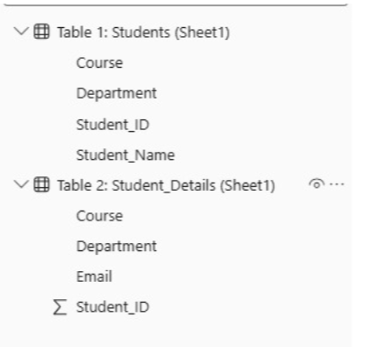

Types of Relationships Created
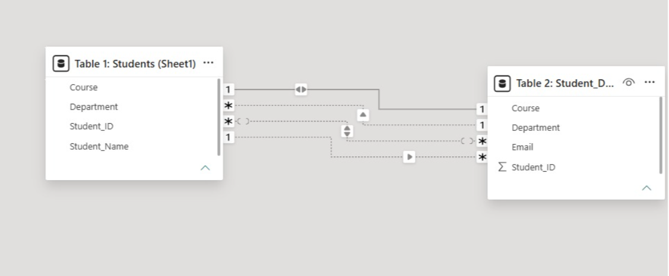
1. One-to-One Relationship
Connection:
Student_ID ↔ Student_ID
Explanation:
One student record matches one detail record.

2. One-to-Many Relationship
Connection:
Department → Course
Explanation:
One department contains multiple courses.

3. Many-to-One Relationship
Connection:
Course → Department
Explanation:
Many courses belong to one department.

4. Many-to-Many Relationship
Connection:
Department ↔ Course
Explanation:
Multiple departments can contain multiple courses.

Conditional Column
A Conditional Column was created to convert short department names into full department names.
Steps Performed
- Open:
Transform Data
- Go to:
Add Column → Conditional Column
- Create conditions based on Department values.
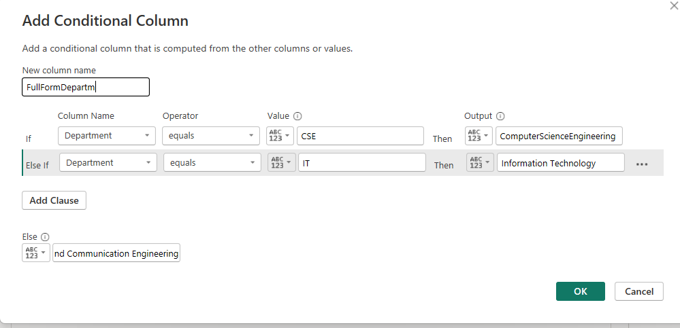

Conditional Column Example
Department | FullFormDepartment
CSE | Computer Science Engineering
IT | Information Technology
ECE | Electronics and Communication Engineering

Conditions Used
If:
Department = CSE
Then:
ComputerScienceEngineering

Else If:
Department = IT
Then:
Information Technology

Else:
Electronics and Communication Engineering
This created a new column named:
FullFormDepartment

Output
The new conditional column successfully displayed full department names automatically based on department short forms.
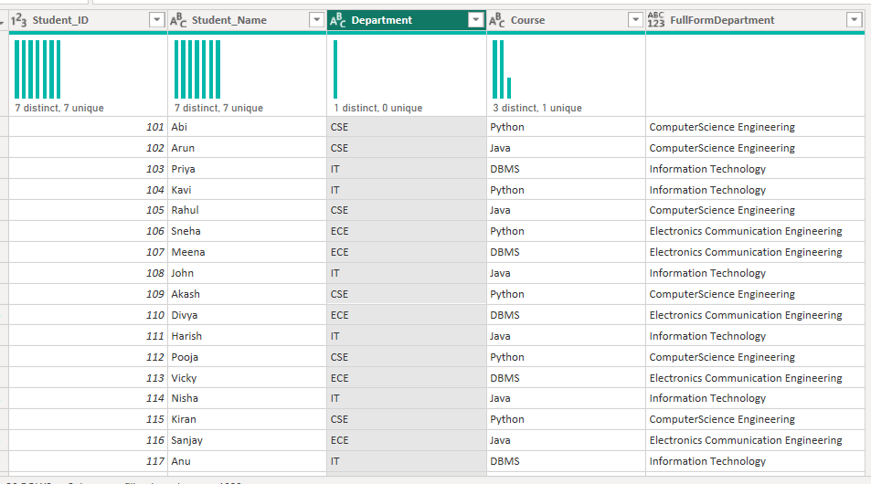
Example:
Department | FullFormDepartment
IT | Information Technology
CSE | Computer Science Engineering
ECE | Electronics and Communication Engineering

Purpose of Dropdown Filter
The dropdown filter helps users:
- filter records easily
- display specific department data
- analyze variations dynamically

Example
When selecting:
IT
from the dropdown,
the output displays:
Information Technology
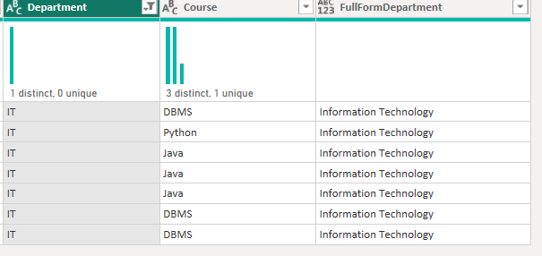
Similarly,
Selected Value | Output Displayed
CSE | Computer Science Engineering
IT | Information Technology
ECE | Electronics and Communication Engineering
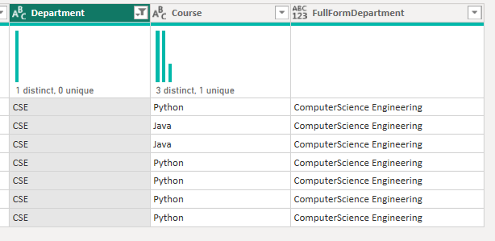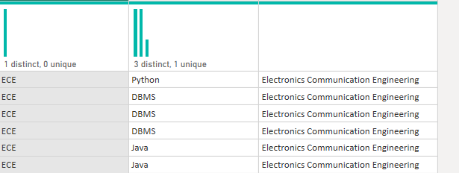
Conclusion
In this session, relationships between tables were successfully created in Power BI using Model View. Different relationship types such as One-to-One, One-to-Many, Many-to-One, and Many-to-Many were understood. Conditional Columns were also created to generate full department names automatically using conditions. These concepts are important for data modeling and data transformation in Power BI.

